
Dashboard Design

Date | [DD Month 2026]
Team ID | [TEAM ID]
Project Name | Global Olympic Sports Performance Analysis
Maximum Marks | 5 Marks

Creating an effective dashboard involves thoughtful design to ensure that the presented information is clear, relevant, and easily understandable for the intended audience. Here are some key principles and best practices for dashboard design
Activity 1: Interactive and visually appealing dashboards
Creating interactive and visually appealing dashboards involves a combination of thoughtful design, effective use of visual elements, and the incorporation of interactive features. Here are some tips to help you design dashboards that are both visually appealing and engaging for users so take care of below points
- Clear and Intuitive Layout
- Use Appropriate Visualizations
- Colour and Theming
- Interactive Filters and Slicers
- Drill-Down Capabilities
- Responsive Design
- Custom Visuals and Icons
- Use of Infographics

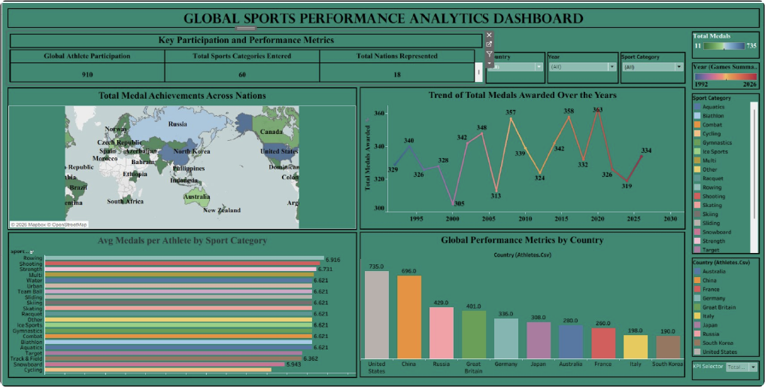
Dashboard 1 – Global Sports Performance Analytics Dashboard
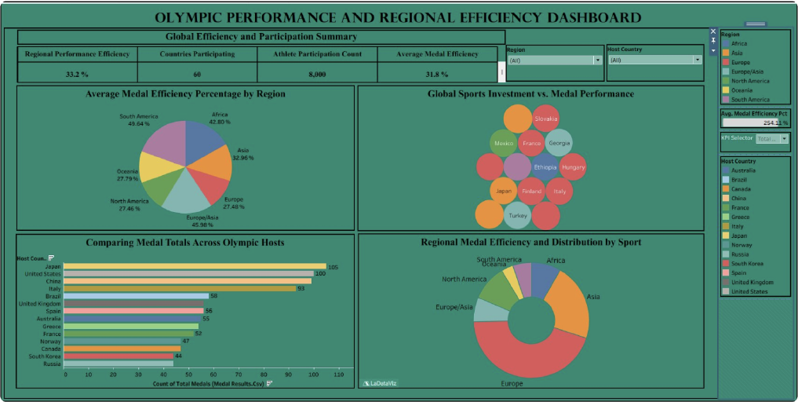
Dashboard 2 – Olympic Performance and Regional Efficiency Dashboard
Note: Highlight the major outcomes in form of bullet points
Major outcomes:
Layout: both dashboards share a dark teal/green theme with gold and white titles, a title banner, KPI tiles at the top, charts in a grid and filter panels on the right.
Dashboard 1 holds the KPI tiles, world map, medal trend line, average medals per athlete by sport category, and global performance metrics by country; filters are Country, Year and Sport Category.
Dashboard 2 holds the regional KPI tiles, average medal efficiency by region (pie), investment vs. medal bubble chart, host-nation comparison and regional donut; filters are Region and Host Country.
Country leaders: the United States (735 total medals) and China (696) are the top performers named in the project. [Verify against the workbook]
Regional efficiency: South America leads at 49.64% followed by Europe/Asia at 45.98%. [Verify against the workbook]
Interactivity: the KPI Selector parameter switches the country chart between Total, Gold, Silver and Bronze, and filters update every chart on a dashboard at once.

Activity 2
Publish Dashboard on Tableau Public and Paste the Dashboard Public link below:
Dashboard public link:
[Paste Tableau Public link for Dashboard 1 and Dashboard 2 here]

